Lab Experiment: Image Processing Operations
Experiment No: 15
Aim
To perform image transformation using the Direct Linear Transformation (DLT) method in Python with the OpenCV library.

Tools Required
- Python 3.x
- OpenCV (cv2)
- NumPy
- VS Code / PyCharm / Jupyter Notebook
- Input Image (e.g., image.jpg)

Procedure
- Install the required libraries:
pip install opencv-python numpy
- Import the required libraries (cv2 and numpy).
- Read the input image using cv2.imread().
- Define four source points and four destination points.
- Compute the transformation matrix using cv2.getPerspectiveTransform() (which implements the Direct Linear Transformation method for four-point correspondences).
- Apply the transformation using cv2.warpPerspective().
- Display the original image and the transformed image.
- Press any key to close the windows.

Code
import cv2
import numpy as np

# Read the image
image = cv2.imread("samplee.jpeg")

# Check if image is loaded
if image is None:
print("Error: Image not found!")
exit()

# Get image dimensions
h, w = image.shape[:2]

# Source points
src = np.float32([
[50, 50],
[w - 50, 50],
[50, h - 50],
[w - 50, h - 50]
])

# Destination points
dst = np.float32([
[0, 0],
[w, 0],
[100, h],
[w - 100, h]
])

# Compute DLT (Perspective Transformation) Matrix
matrix = cv2.getPerspectiveTransform(src, dst)

# Apply the transformation
output = cv2.warpPerspective(image, matrix, (w, h))

# Display images
cv2.imshow("Original Image", image)
cv2.imshow("DLT Transformation", output)
cv2.waitKey(0)
cv2.destroyAllWindows()

Output
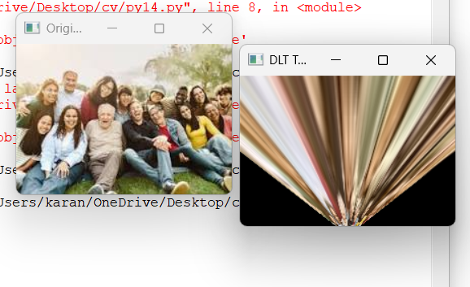
Result
The input image was successfully transformed using the Direct Linear Transformation (DLT) method in Python with the OpenCV library. The transformed image was displayed successfully.

